**Data Methodology for PPT 01**

**Step 1: Storyboarding**

* Examined the data to become acquainted with it and made a note of any significant fields.
* Made a mental map of the presentation's different slides.
* Enumerated all the characteristics for which graphs and charts must be plotted.

**Step 2: Data Wrangling**

* Imported the dataset in Python Notebook and go through the all the columns.
* Also checked the missing values in all the columns.

id 0

name 16

host_id 0

host_name 21

neighbourhood_group 0

neighbourhood 0

latitude 0

longitude 0

room_type 0

price 0

minimum_nights 0

number_of_reviews 0

last_review 10052

reviews_per_month 10052

calculated_host_listings_count 0

availability_365 0

dtype: int64

* Treated Missing values by using Python & attached the Python Notebook in zip file.
* Used Tableau to further visualize the modifications that were exported to a CSV file.
* Created some grouped field & calculated field.

**Step 3: Data Analysis**

* Over half of the hosts prefer to rent out the full home or apartment.
* Private rooms and the complete home or apartment appear to be popular (more than 90% evaluations).
* 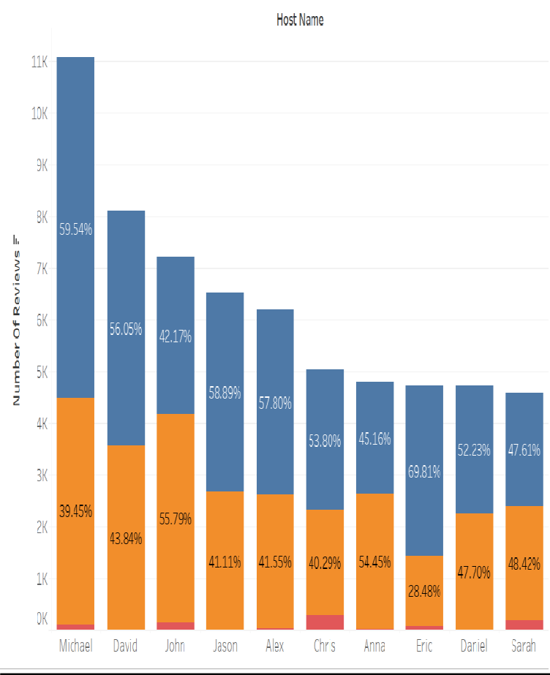Shared rooms have the fewest reviews out of all the listed properties.
* Because Manhattan and Brooklyn are pricey locations, 20% of reservations are made there.
* Most guests choose to stay for less than three nights.
* 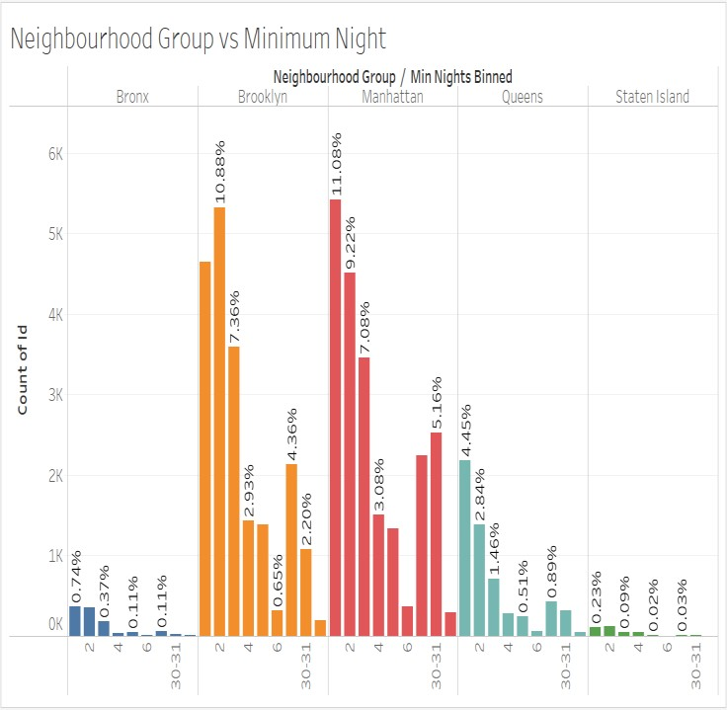Only 10% of individuals choose renting in the Bronx, the poorest borough, whereas Staten Island is continuously developing.
* Also attaching the Tableau workbook in zip file.

**Step 4: Presentation**

* Made the presentation using the pyramid approach and best practices.
* The people watching this are the **Data Analysis Managers** & **Lead Data Analyst**
* Added recommendations for the respective departments.